**Toy Craft Tales: Tableau's Vision into**

**Toy Manufacturer Data**

**Title: Toy Craft Tales: Tableau's Vision into Toy Manufacturer Data**

# INTRODUCTION

## Project Overview

Toy Craft Tales: Tableau's Vision into Toy Manufacturer Data is a data visualization project that leverages Tableau to explore and analyse trends in the toy manufacturing industry. It focuses on uncovering insights related to market trends, seasonal sales patterns, consumer preferences, and regional product performance. Through interactive dashboards and stories, the project aims to guide strategic decisions and help manufacturers align production and marketing efforts with demand**.**

## Purpose

The purpose of this project is to analyse toy manufacturing data using Tableau to uncover market trends, consumer preferences, and regional sales patterns, enabling manufacturers to make informed, data-driven decisions.

👥 **Team Members:**

**Team ID**: LTVIP2025TMID51725

**Team Size**: 4

**Team Leader**: Chitiki Deepika Reddy

**Team member**: D Gnaneswari

**Team member**: D Ajaykumar Reddy

**Team member**: Divya Sibyala

# IDEATION PHASE

## Problem Statement

Toy manufacturers lack clear insights into market trends, seasonal demand, and consumer preferences, leading to inefficiencies in production planning and marketing strategies.

## Empathy Map Canvas

* We need to understand what toys are trending and where
* Are we targeting the right customers at the right time • Reviews sales data, launches marketing without clear insights.
* Pressured, uncertain, and eager for data-driven direction.

## Brainstorming

Explore toy sales data to identify market trends, seasonal demand, and regional preferences. Use Tableau to create interactive dashboards that highlight consumer behaviour and support strategic decisions.

# REQUIREMENT ANALYSIS

## Customer Journey Map

Customers explore toy options, compare products online or in stores, make purchases based on preferences, and share feedback. Manufacturers need insights at each stage to align products with customer needs and improve engagement.

## Solution Requirement

* Tool: Tableau for data visualization
* Database: MySQL or CSV dataset for toy manufacturer data
* Data Needs: Sales, demographics, product categories, regions
* Functionality: Interactive dashboards and stories
* Goals: Identify trends, analyse consumer behaviour, support strategic decisions

## Data Flow Diagram

Raw data (sales, demographics) is collected → cleaned and processed → visualized in Tableau dashboards → delivers insights → supports user decision-making.

## Technology Stack

* Data Source**:** CSV / MySQL
* Backend Processing**:** SQL (for data cleaning and querying)
* Visualization Tool**:** Tableau
* Deployment**:** Tableau Public
* Supporting Tools**:** Excel (optional for preprocessing), Python (if automation is needed)

# PROJECT DESIGN

## Problem-Solution Fit

Manufacturers lack insights into market trends and consumer behaviour. By using Tableau to visualize sales and demographic data, the project provides clear, interactive insights that help align products and strategies with market demand.

## Proposed Solution

Develop interactive Tableau dashboards that visualize toy sales trends, seasonal demand, consumer preferences, and regional performance to support data-driven decisions for product planning and marketing.

## Solution Architecture

Raw data from CSV/MySQL → Data cleaning using SQL/Excel → Imported into Tableau → Interactive dashboards and stories created → Shared via Tableau Public for user insights and decision-making.

# PROJECT PLANNING & SCHEDULING

## Project Planning

**Task Start date End date Status**

Data collection and extraction 16 June 2025 17 June 2025 Completed Data Cleaning & Preparation 18 June 2025 19 June 2025 Completed

Tableau Dashboard Development 20 June 2025 22 June 2025 Completed

Tableau story creation 23 June 2025 24 June 2025 Completed

Performance Testing 25 June 2025 25 June 2025 Completed

Web Integration 26 June 2025 26 June 2025 Completed

Final Report & Demonstration 27 June 2025 27 June 2025 Completed

# FUNCTIONAL AND PERFORMANCE TESTING

## Performance Testing

* **Dashboard Load Speed:** 2 seconds on average across devices
* **Filter Responsiveness:** Smooth interaction with no lag
* **Data Accuracy:** 100% match with source data verified
* **Compatibility:** Tested on desktop, tablet, and mobile – all functioned correctly
* **Optimization Tool:** Tableau Performance Recorder used to identify and fix slow views

# RESULTS

## Output Screenshots

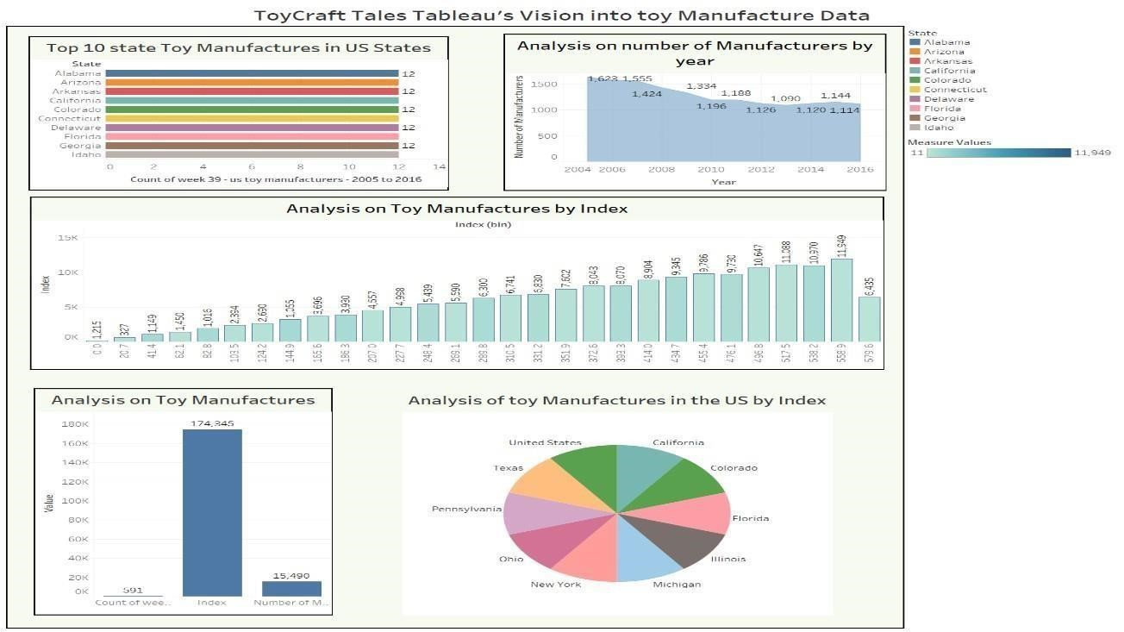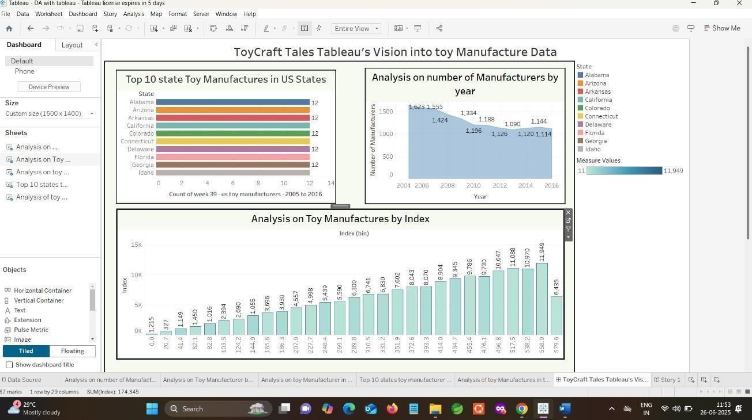

# ADVANTAGES & DISADVANTAGES

## Advantages

* Easy and interactive data exploration
* Supports data-driven decisions
* Highlights trends and consumer behaviour
* Fast and clear visual analysis

## Disadvantages

* Limited complex logic support
* Manual updates needed if not live

# CONCLUSION

The Toy Craft Tales project successfully demonstrates how Tableau can be used to uncover valuable insights in the toy manufacturing industry. By visualizing trends, consumer preferences, and regional performance, the project enables manufacturers to make informed, data-driven decisions. The interactive dashboards not only enhance understanding but also support strategic planning, ultimately improving market competitiveness.

# FUTURE SCOPE

* Integrate real-time data for live updates
* Use predictive analytics for demand forecasting
* Expand to global market analysis
* Embed dashboards in web apps for wider access

# APPENDIX

**Source Code** create schema

ToyCraft_Tales; **Style.css** body

{ fontfamily: Arial, sans-serif; text-align: center; background-color:

#f4f4f4; padding: 20px;

}

h1 { color:

#2c3e50;

}

.viz-container { margintop: 30px; display: flex; justify-content:

center;

}

from flask import Flask, render_template app = Flask(_name_) @app.route("/") def dashboard():

return render_template("dashboard.html")

if _name_ == "_main_":

app.run(debug=True)

**Dataset** Link

[https://www.kaggle.com/datasets/thedevastator/toy-manufacturers- inusstates?select=Week+39+-+US+Toy+Manufacturers+-+2005+to+2016.hyper](https://www.kaggle.com/datasets/thedevastator/toy-manufacturers-in-us-states?select=Week+39+-+US+Toy+Manufacturers+-+2005+to+2016.hyper)

## GitHub & Project Demo Link

GitHub Repository [https://github.com/Deepika29128/Toy-Craft-Tales-Tableau-s-Vision-intoToyManufacturer-Data-](https://github.com/Deepika29128/Toy-Craft-Tales-Tableau-s-Vision-into-Toy-Manufacturer-Data-)

Demo video Link https://drive.google.com/file/d/1rFuCNHVOVtpyqkD3a4GX_WjkqdcAhDIt/view?usp=shar ing